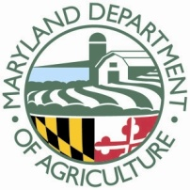
Tax Credit Certificate Administrator Number: MD ATCA 005
FOOD DONATION PROGRAM TAX CREDIT CERTIFICATE

DONATION DATE: | ____________________________________________
PRODUCER/FARM NAME: | ____________________________________________
CONTACT NAME: | ____________________________________________
ADDRESS: | ____________________________________________
 | ____________________________________________
COUNTY: | ____________________________________________
PHONE NUMBER: | ____________________________________________
EMAIL ADDRESS: | ____________________________________________
FEDERAL TAX ID/SOCIAL SECURITY: | ____________________________________________
COMMODITY/TYPE OF DONATION: | ____________________________________________
WEIGHT: | ____________________________________________
MEASUREMENT/UNIT/PACKAGE: | ____________________________________________

SIGNATURE: ____________________________________________

Farmers: Email signed and scanned forms to:
Tricia Thomas, Manna Food Center, tricia@mannafood.org

Manna will send form with TCCA Donation Receipt to: MDA Marketing Office, ATTN: Food Donation Program, marylands.best@maryland.gov

