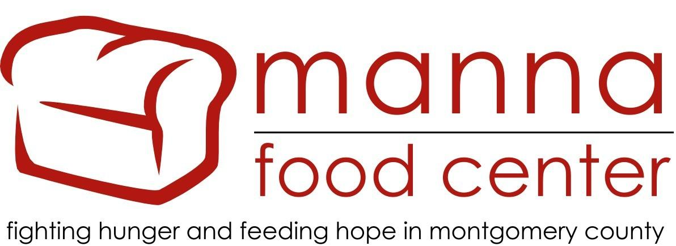

September 13, 2021
Montgomery County Farm to Food Bank Guide
Montgomery County’s Farm to Food Bank program is a partnership between the Montgomery County Food Security Task Force, the Department of Health and Human Services, Manna Food Center, the Montgomery County Food Council, and the Montgomery County Office of Agriculture. The Farm to Food Bank program strengthens the County’s food economy by supporting farmers and provides better access to fresh, local, nutritious food for residents experiencing food insecurity. Manna Food Center received funding from the County and the Greater Washington Community Foundation through the “Food for Montgomery” campaign to purchase produce, eggs, meat and other County-grown products from local farms.
How the program works
To administer the County’s Farm to Food Bank program, Manna Food Center’s Community Food Rescue (CFR) Program will work directly with farmers and CFR network food assistance organizations. Susan Wexler, CFR Outreach Coordinator is the main point of contact. You can reach her at Communityfoodrescueoutreach@mannafood.org and cell phone 301-938-9725.
When you have a product(s) for purchase through Farm to Food Bank, you will complete a Farmer Offer form on ChowMatch with date(s) you want to sell products.
- Signing up - If you are not already a member of Community Food Rescue, please sign up as a food donor and create your account, through the free CFR matching tool, ChowMatch. Despite the fact that you are signing up as a donor, this is the designation for farms that are looking to sell product. If you also wish to donate food, we will create a separate Donation Account. See below for more details.

- Pricing and packaging - We use the Price Suggestions - Farm to Food Bank sheet as a guide for what we will pay for certain items. If you object to a price suggested here for a particular item you sell, or if there is a product that hasn’t been priced yet, please contact Jenna@mannafood.org to negotiate a price before the offer is made.
  - Packaging – Please package any Farm to Food Bank product in packaging that you don’t expect to be returned to you. If needed, you can add the cost of non-reusable packaging to your invoices. We welcome suggestions for how to incorporate more reusable solutions! If you have any, please discuss them with Susan Wexler (communityfoodrescueoutreach@mannafood.org).

- Transportation - You will have the option to deliver directly to a food assistance organization or, if desired (and the quantity allows), have the produce picked up and delivered by CFR volunteer food runners. Food runners cannot take more than 500 lbs. of food at one time. We can set up multiple food runs if there is more than 500 lbs. at one time. You must group together and label your food as follows: CFR for purchase. This distinguishes it from any food you offer for donation or any other kind of pick up you may have. Make sure to have food ready at the time designated for pick up. Some high-volume products like greens may require more than one car regardless of product weight. In this case, we may schedule two food runs in the same time frame and you will see a confirmation of each

- Making an offer - When you have food to sell, login to your ChowMatch account (See #1 above). Go to the Donor dropdown menu. Click on Schedule Farm to Food Bank. Under Donor and Location, select your farm_PURCHASED. Fill in the offer form. You may now make an offer on any business day. On the offer form, please note the following details:
  - Pick up date/time. Schedule your pick-up date range from the earliest to latest your product will be of top quality. We will try to place your offer as soon as possible. Allow at least two business days from the time the offer form is submitted for the product to be picked up. It’s best to prepare and pack your harvest for pick up, unless you are notified otherwise. Note that we may not be able to accept all products in your offer due to an overabundance of certain foods. In which case, you will be notified via email within two business days.
  - You can either enter a date and time range or select a single date. You must enter at least a one hour pick up time frame, and entering a longer timeframe is helpful for volunteer food runners.
  - Product(s). Start typing the product name and select from the drop down list. If your product is not listed, add it on the “other info” line.
  - Number of Units
  - Unit(s) type. Select from the dropdown list. Or if your unit type is not listed, enter it into the “other info” line. Please always enter both unit type AND pounds. This is important because it allows us to track the balance of funds in the current program.
  - Total amount per item. Enter the weight in pounds.
  - Packaging - e.g. box, bag, or clamshell. Enter this info into the “other info” line next to each product
  - If you have more than five products, click on Additional Food Items for more lines.
  - Add a summary if you need to explain more here.
  - Add detailed pick-up instructions so that a food runner can locate and pickup.
  - Check one box: Can you deliver or do you require a pickup?
  - Click continue; review information on next screen, then click continue. YOUR OFFER WILL BE REVIEWED.

Once your product is matched with one or more of the 104 Community Food Rescue network (CFR) food assistance organizations, pick up or delivery, you will get an email from ChowMatch when your offer has been accepted.

- Get product ready for pick up- Make sure that products are in appropriate packaging as listed. Place food items out for pick up by the time listed. Make sure to label all food: CFR for PURCHASE.

- If at the time of pick-up you are providing more or less than what was indicated on your offer form, please email Susan and correct the amounts. Please invoice for exactly the amount that was ultimately picked-up.

- Invoicing - Susan will confirm that produce was received by the organization(s). Please invoice Manna Food Center for confirmed purchases using this Invoice Template and send invoices to Jenna@mannafood.org.

- Payment will be made within 30 days of receipt of invoice.
If you have any questions, please contact Susan Wexler, communityfoodrescueoutreach@mannafood.org or 301-938-9725.
Food Donations
If you wish to donate food through Community Food Rescue, you may do so at any time and schedule the food run yourself by following these steps:
In ChowMatch, under Donor drop down menu, select Schedule a Food Run. Click on Location and choose your farm_DONATED account. Fill in the form with specific food type, quantity, date and time for pick up and any other details.
ChowMatch will automatically match your donation with one of the CFR network food assistance organizations. You will receive a confirmation of the food run once a volunteer food runner accepts this run. To claim a tax credit for your donation, contact Cheryl Kollin, CFR Program Director, Cheryl@communityfoodrescue.org for more information and forms to submit.

